# *Article*

**A survey on Artificial Intelligence utility in Electric Vehicles**

# Author 1 1, Author 2 [1,](https://orcid.org/0000-0002-6913-2517)

1. Department – Author 1
2. Department **–**Author 2

Correspondence:; Tel.:

**Abstract:**

The paper describes the Design and Implementation of a closed loop control in PSFB topology using Artificial Intelligence. In Power Electronics, converter raw input power is processed based on control input, generating the output power. The control input may be differentiated based on various topologies like PFC, LLC, and PSFB depending upon the application. Precisely, the paper talks about the control algorithm that controls this power. The same can be done by analog components or digital controllers. Digital Controllers have effectively replaced Analog components due to its advantages like Flexibility, cost, and space. Digital controllers work better on closed loop control for accuracy and to automatically adjust based on the change in output. The topology being used here is PSFB (Phase Shift Full Bridge) which consists of 4 Switches/MOSFETs driven by PWM. The output power yield depends on the phase shift between the PWM’s. There are various dynamic factors that affect the stability of the control system like load, input, noise, operation mode, etc. The controller used is PID (Proportional Integral Differential) which is often manually tuned to achieve optimum stability. This effectively means converter stability will not be the same under all conditions. In embodiments within, we are using Reinforcement Learning to solve this problem and achieve the best possible control coefficients. Reinforcement Learning is a method in which Software can learn through the factors that have given the best output for a given period of time. It works on getting rewards when the output reaches closer to the expected value. Different reward functions may be defined to achieve a single tuned combination with all possible outcomes like less overshoot, lesser ringing, etc. Overall, the proposed solution helps automate the tuning of the control loop thus reducing the time and effort and giving higher accurate results as well

**Keywords:** Power Electronics converter; Artificial intelligence ; Electric Vehicle; Reinforcement Learning

## 1. Introduction

## 2. AI in Power Electronic Components of Vehicle

Electric Vehicle consists of several Power Electronic Components like DCDC Converter – to convert power from HV Battery to Low Voltage to power low voltage components like wiper, headlights, etc. Charger – to charge HV Battery, it converts AC grid Voltage to DC Voltage for HV Battery. Motor Control Unit – to power the motor which helps the Vehicle to run. There has been a rapid development in terms of PE Components, which includes transforming all Analog components into digital. Thus, Software has become an integral part of PE Converters. As it is a continuously developing field there are still some limitations such as stability, noise, tuning of the converter, etc. AI being an emerging field has proven beneficial in the Power Electronics field to eradicate these limitations.

One such utilization is to tune Controllers. Converters utilize control system techniques for stability, and accuracy for closed loop systems. One major benefit of closed loop systems being it adapts themselves based on output hence ensuring accuracy. Modern day Converters mostly use Software for these control systems. But these control loop whether it is Hardware or Software needs to be tuned. Conventionally, these control systems are being tuned based on hit and trials and manual approaches but in very recent methodologies suggested AI can be used for tuning these systems automatically [1].

Figure 1[2] depicts a typical digital control system. Where the input signal is represented by r (t), the input signal precisely means the calculated target output of the converter. Then error is calculated between input and sensed output. As the control algorithm is written inside the controller, it needs to be discretized. An ADC (Analog to Digital Converter) is used for the conversion. After control calculations again digital values are converted and fed to the plant. Again same output goes for error calculation, same way the control loop keeps on running minimizing the errors.

The control algorithm used is PID, stability of the converter depends on this PID Algorithm, precisely on coefficients kp, ki, kd.

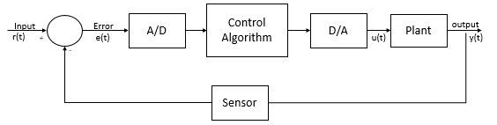

**Figure 1.** Typical Digital Control System

Here, to demonstrate the use of AI, we are taking an example of a buck converter. Figure 2 shows a simple buck converter circuit which we are going to digitise, it consists of switching MosFet, together with the inductor, diode, and capacitor. When MosFet is on, current is flowing via L1. Inductor opposes current hence avoiding the peaks at output and later releases back. As current builds up slowly at C1 during on period, there is ;large voltage at Diode. Hence, diode does not come into action.

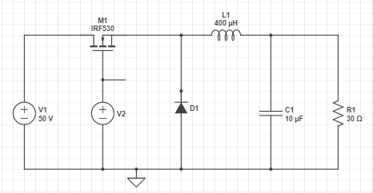

**Figure 2.** Typical Digital Control System

Figure 3 depicts simulation results. The Red waveform is Voltage on the 30 Ohm Load. As seen the voltage on load rises and then stabilises slowly. The green trace shows the 50V circuit supply Voltage. Blue waveform depicts Gate pulses.

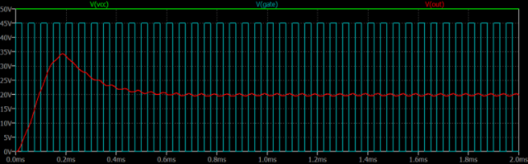

**Figure 3.** Simulation results of Buck Converter

## 3. ABC

### 3.1. CED

### 3.2. efg

## 4. ABC

### 4.1. ghjg

### 4.2. sjk

## 6. Conclusions

**Author Contributions:**

**Funding:**

**Conflicts of Interest:** The authors declare no conflict of interest.

# References

1. 1. https://ieeexplore.ieee.org/document/9178190
2. 2. <http://www.gvpcew.ac.in/LN-CSE-IT-22-32/EEE/4-Year/DCS.pdf>
3. [https://www.ijert.org/research/digital-control-of-dc-dc-buck-converter-IJERTV1IS7038.pdf].
4. [Stability analysis of a phase-shifted full-bridge circuit for electric vehicles based on adaptive neural fuzzy PID control | Scientific Reports (nature.com)](https://www.nature.com/articles/s41598-021-99559-4)
5. [Tune_Your_PID_Controller_With_AI.pdf (smartr.ai)](http://smartr.ai/assets/Tune_Your_PID_Controller_With_AI.pdf)